**Interim Behavior Response Plan (IBRP)**

|  |  |
| --- | --- |
| **Student Name**:  Click or tap here to enter text. | **Date of Plan**:  Click or tap here to enter text. |
| **School Team Developing Plan**:  Click or tap here to enter text. | **School**:  Click or tap here to enter text. |

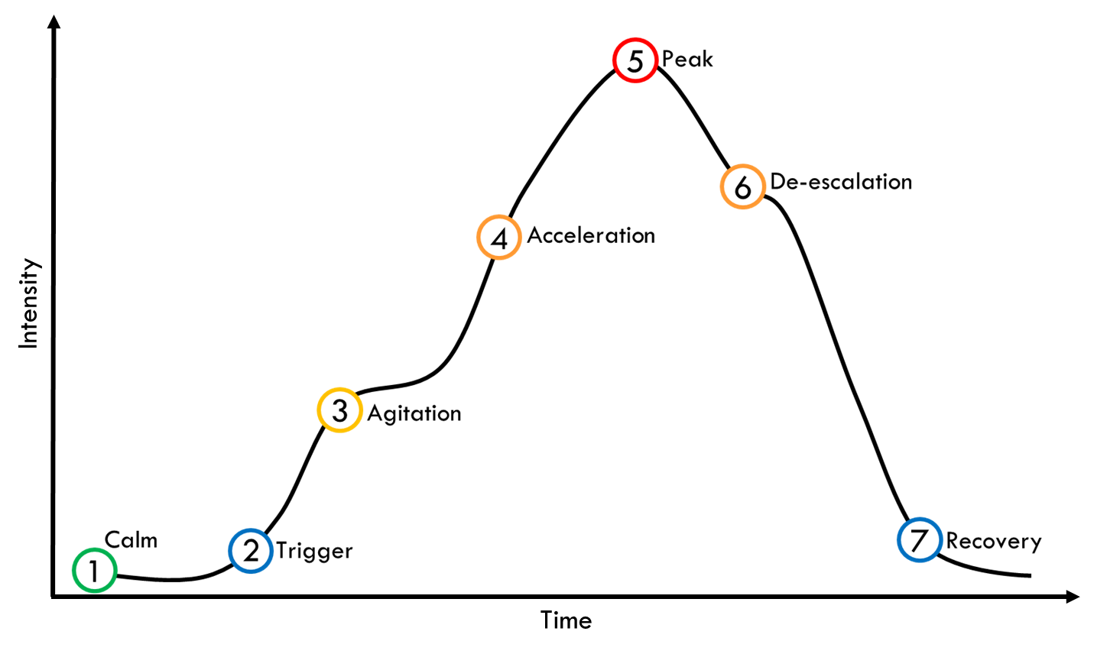

|  |  |  |  |
| --- | --- | --- | --- |
| **Calm** | **Student Behavior** | | **Staff Responses** |
| * Click or tap here to enter text. | | * Click or tap here to enter text. |
| **Triggers** | **Identify Known Triggers** | **Student Behavior** | **Staff Responses** |
| * Click or tap here to enter text. | * Click or tap here to enter text. | * Click or tap here to enter text. |
| **Agitation** | **Student Behavior** | | **Staff Responses** |
| * Click or tap here to enter text. | | * Click or tap here to enter text. |
| **Acceleration** | **Student Behavior** | | **Staff Responses** |
| * Click or tap here to enter text. | | * Click or tap here to enter text. |
| **Peak** | **Student Behavior** | | **Staff Responses** |
| * Click or tap here to enter text. | | * Click or tap here to enter text. |
| **De-escalation** | **Student Behavior** | | **Staff Responses** |
| * Click or tap here to enter text. | | * Click or tap here to enter text. |
| **Recovery** | **Student Behavior** | | **Staff Responses** |
| * Click or tap here to enter text. | | * Click or tap here to enter text. |

After an incident staff should debrief to discuss what happened and determine any modifications/revisions needed.